PROJECT REPORT
Team ID | PNT2022TMID03463
Project Name | AI based discourse for Banking Industry
Team members | Subiksha K P  Kavya V G  Pavithra S  Siva Vadivu Ragavi V

- INTRODUCTION
  - PROJECT OVERVIEW
Banking organizations across the world are leaning towards technology to provide better experience to their customers. The rise of chatbots within the finance sector is that the latest turbulent force that has modified the approach customers move. within the industry, the introduction of computing has driven chatbots and altered the face of the interaction between banks and customers. A chatbot may be an informal agent that uses the tongue to speak with users. Chatbots have a ton of edges together with a 24/7 client service, timely responses and effective inquiry handling, reduced price of client service and best client satisfaction. They vanquish humans in terms of speed and accuracy. The chatbot has been used Over the past few years, however, the use of bots has attracted industries. Chatbots were first set up in the 1960s and have come a long way from their initial development.

1.2 PURPOSE
Abstract Artificial intelligence (AI) is now widely acknowledged as one of the most important digital transformation enablers across a significant number of industries. Artificial intelligence (AI) has the potential to facilitate enterprises. become more imaginative, versatile, and adaptable than they have ever been. AI is already being applied to enhance productivity and competitiveness while also driving digital transformation in a range of organizations. AI is supporting banks in upgrading their operations across the board, from accounting to sales to contracts and cybersecurity.

- LITERATURE SURVEY
TITLE: Intelligent chatbot for banking system
AUTHOR: Mr.Anikat dole, Mr.Hrushikesh sansare, Mrs.Sprooha Athalye
YEAR: 2015
An intelligent chat bot will be used to give information or answers to any question asked by user related to bank. Our Intelligent system will first take input from bank customer. This input will be taken as voice or written format. According to input, intelligent system will processes the query and give response to user. An artificial intelligence is most important and helpful part of our project. This system will be available on web. Our system will represent the design and development of an intelligent chat bot. It will present a technology demonstrator to verify a proposed framework required to support such a bot (a web service). While a black box approach is used, by controlling the communication structure, to and from the web-service, the web-service allows all types of clients to communicate to the server from any platform. The service provided will be accessible through a generated interface which allows for seamless XML processing; whereby the extensibility improves the lifespan of such a service.

TITLE: Ai based chatbot for human assistance AUTHOR: Sanchit Singhal, Vatsal Garg, Harsh khatter. YEAR:2020
Chatbot is an implementation of Artificial Intelligence technology which is used to interact with the human beings and make them feel like they are taking to the real person and the chatbot helps them to solve their queries. A chatbot can provide 24*7 customer support so that the customer may have the good service experience by any organization. The user is providing the input to the chatbot first and then the same input will process further and this input can be in the form of text or voice. This response can be in any format like text format or a voice output. This chatbot is built using Dialogue Flow (Google-owned) and it can be accessible through mobile phones, laptops and portable devices. Chatbots such as Facebook bot, WeChat bot, Hike bot called Natasha, etc are available in the marker and will respond on the basis of their local databases. This chatbot uses unification of emerging technologies like Machine learning and Artificial Intelligence. The motive of this Chatbot system is to support and scale businesses and maintain relations with customers. The main aim of this chatbot is to enhance the customer support experience so that the customer can get support at any time, at any place and on any device in a very less time.

TITLE: Artificial intelligence based chatbot
AUTHOR: Tushar Gaikwad
YEAR: 2018
A Chat-bot is computer program which conduct a conversation via auditory or textual method. A Chabot are software agent that interacts with the user for conversation. Chatbot typically serve text based user interface allow input from user and receive text as well as auditory from output.
Information of chatbot are stored in database which is consist database who provide by owner of shop and requirement of user. This system will be provided answers to the query of the user very effectively. User just have to put their requirement to the chatbot which is used for conversation. The system will used the AI algorithm to give appropriate answer to the user. If the answer is invalid then system declares answer is invalid. This invalid answer can be deleting or modified to by admin. One of the most popular engines are used for regular expression base natural language processing engine called verbot. This makes it easy designer chat-bot & automates conversation with user.

TITLE: Approaches towards building a banking assistant system.
AUTHOR: M.S.Shetty, Rajni pamnani.
YEAR: 2017
Banking process has been very complicated since
years. People often want to enquire about bank’s policies on the bank counter and since the policies are sometimes confusing, it takes time for them to understand the policy and thus, the process. This paper presents two approaches one using Natural Language Processing techniques and other using AIML, a popular language for building chatbots for building banking assistant which can solve people’s queries and also carry out certain banking tasks, thus avoiding loss of efficiency and loss of precious time of the people. The paper is aimed at providing interface to the users which enables communication for solving their queries and completing their tasks, thus saving their time and reducing any possible confusion.
TITLE: Banking with a chatbot. AUTHOR: Monica anetta, Ibolya vizali. YEAR: 2021
The implementation of chatbot technology is evolving rapidly in the banking industry. yet customer acceptance is behind. The aim of the present paper is to identify factor that influence customer perceived privacy risk and awareness of the service. The sample contains 287 respondents, out of whom 24% have previously used a chatbot. Awareness of the service has an effect on perceived ease of use, perceived privacy risk and it indirectly affects usage intention of banking chatbots through perceived usefulness and perceived compatibility has an effect on both perceived ease of use and perceived usefulness. perceived ease of use and perceived privacy risk show no effect on usage intention.

TITLE: Conversation to automation in banking through chatbot.
AUTHOR: Shasha Fathima suhel, Vinod kumar sukhla, Sonali vyas.
YEAR: 2020
Artificial Machine Intelligence is a very complicated topic. It involves creating machines that are capable of simulating knowledge. This paper examines some of the latest AI patterns and activities and then provides alternative theory of change in some of the popular and widely accepted postulates of today. Based on basic A.I. (Artificial Intelligence) structuring and working for this, System-Chatbots are made (or chatter bots). The paper shows that A.I is ever improving. As of now there isn't enough information on A.I. however this paper provides a new concept which addresses machine intelligence and sheds light on the potential of intelligent systems. The rise of chatbots in the finance sector is the latest disruptive force that has changed the way customers interact. In the banking industry, the introduction of Artificial Intelligence has driven chatbots and changed the face of the interaction between bank and customers. The banking sector plays an important role in development into any country.
TITLE: Modern development trends of chatbots using Artificial intelligence.
AUTHOR: Julija skrebeca, Paula kalniete.
YEAR:2021
Artificial Intelligence-powered chatbots can work as intelligent teaching systems, for providing a personalized way of learning for students. Chatbot reviews student’s responses and his learning progress. One of the most convenient features of chatbots is the opportunity to send lecture materials in the form of messages to students as if it is just a chat with a friend. Apart from personalized chatbot usage in the studying process, it can be used to streamline business processes, e.g., such as sales.

  - EXISTING PROBLEM
A chatbot enables a user to simply ask questions in the same manner that they would respond to humans. The most well- known chatbots currently are voices chatbots: SIRI and Alexa. A bot is trained on and according to the training, based on some rules on which it is trained, it answers questions. It is called ruled based approach. The language by which these bots can be created is Artificial Intelligence Markup Language (AIML). It is a language based on XML which allows the developer to write the rules which the bot will follow. These existing system requires much technologies to integrate and requires a lot of data to be fed for training which makes the process slower.

  - REFERENCES
1. https://www.financialdirector.co.uk/2019/10/03/ai-for-financial-directors-and-cfos/
2. Aazhvaar, V. (2019). ARTIFICIAL INTELLIGENCE IN INDIAN BANKING SECTOR: CHALLENGES AND OPPORTUNITIES. International Journal of Advanced Research, April 7(5), 1581-1587.
3. Alam, M., & Khokhar, R. (2006). Impact of Internet on Customer Loyalty in Swedish Banks. J. Econ. Psychol. Apr 7;16:311-29.
4. Ardito, L., Petruzzelli, A. M., Panniello, U., & Achille, C. (2019). Towards Industry 4.0. Business Process Management Journal , Bradford Vol. 25, Iss. 2, pp: 323-346.
5. Awad, R. (2011). Considerations on Cloud Computing for CPAs. The CPA Journal , New York Vol. 81, Iss. 9, Sep pp: 11-12.
6. Ayachit, M. M. (2017). ICT Innovation in Indian Banking Sector: Trends and Challenges. IOSR Journal of Business and Management (IOSR-JBM), PP 21-27.
  - PROBLEM STATEMENT DEFINITION
Banking is one the crucial sector, it deals with financial transactions which can be availed by everyone, but banks are not able to resolve the queries of customers at all times related to the products or services in satisfactory way in turn hinders the customer satisfaction. In order to guide the customers throughout all the financial services provided by the bank, an intelligent system has to be introduced to provide people with the best solution possible. The users are bank customers who needs 24/7 service to clear all their queries and guide them through all the banking processes. So, an enhanced and smarter way of interaction with the customers has to be built to ensure efficient delivery of service. In order to overcome the user satisfaction issues associated with banking services, chatbot will provide personal and efficient communication between the user and the bank. It is built to be the overall virtual assistant that can facilitate customers to ask banking- related questions without visiting the bank or calling up customer service centres as well as providing them with relevant suggestions.

Who does the problem affect? | A customer of the bank
What are the boundaries of the problem? | Customers who have queries related to  banking or trying to use various services of the bank
What is the issue? | Customers need to visit banks frequently for simple queries. Banks are not able to answer  huge volumes of customers queries efficiently.
When does the issue occur? | When the customer is unable to visit a bank
Where does the issue occur? | It occurs in banking industries
Why is it important that we fix the problem? | It addresses the queries of customers immediately and effectively in a cost efficient  manner.
What solution to solve this issue? | Chatbot should be able to answer any general banking queries on account creation, loan, net banking, other services etc. AI chatbots can  help the customers to complete their work quickly and efficiently.
What methodology used to solve the issue? | Artificial intelligence mimics the human brain in order to make chatting with the chatbot  more life- like.

- IDEATION & PROPOSED SOLUTION
  - Empathy Map Canvas

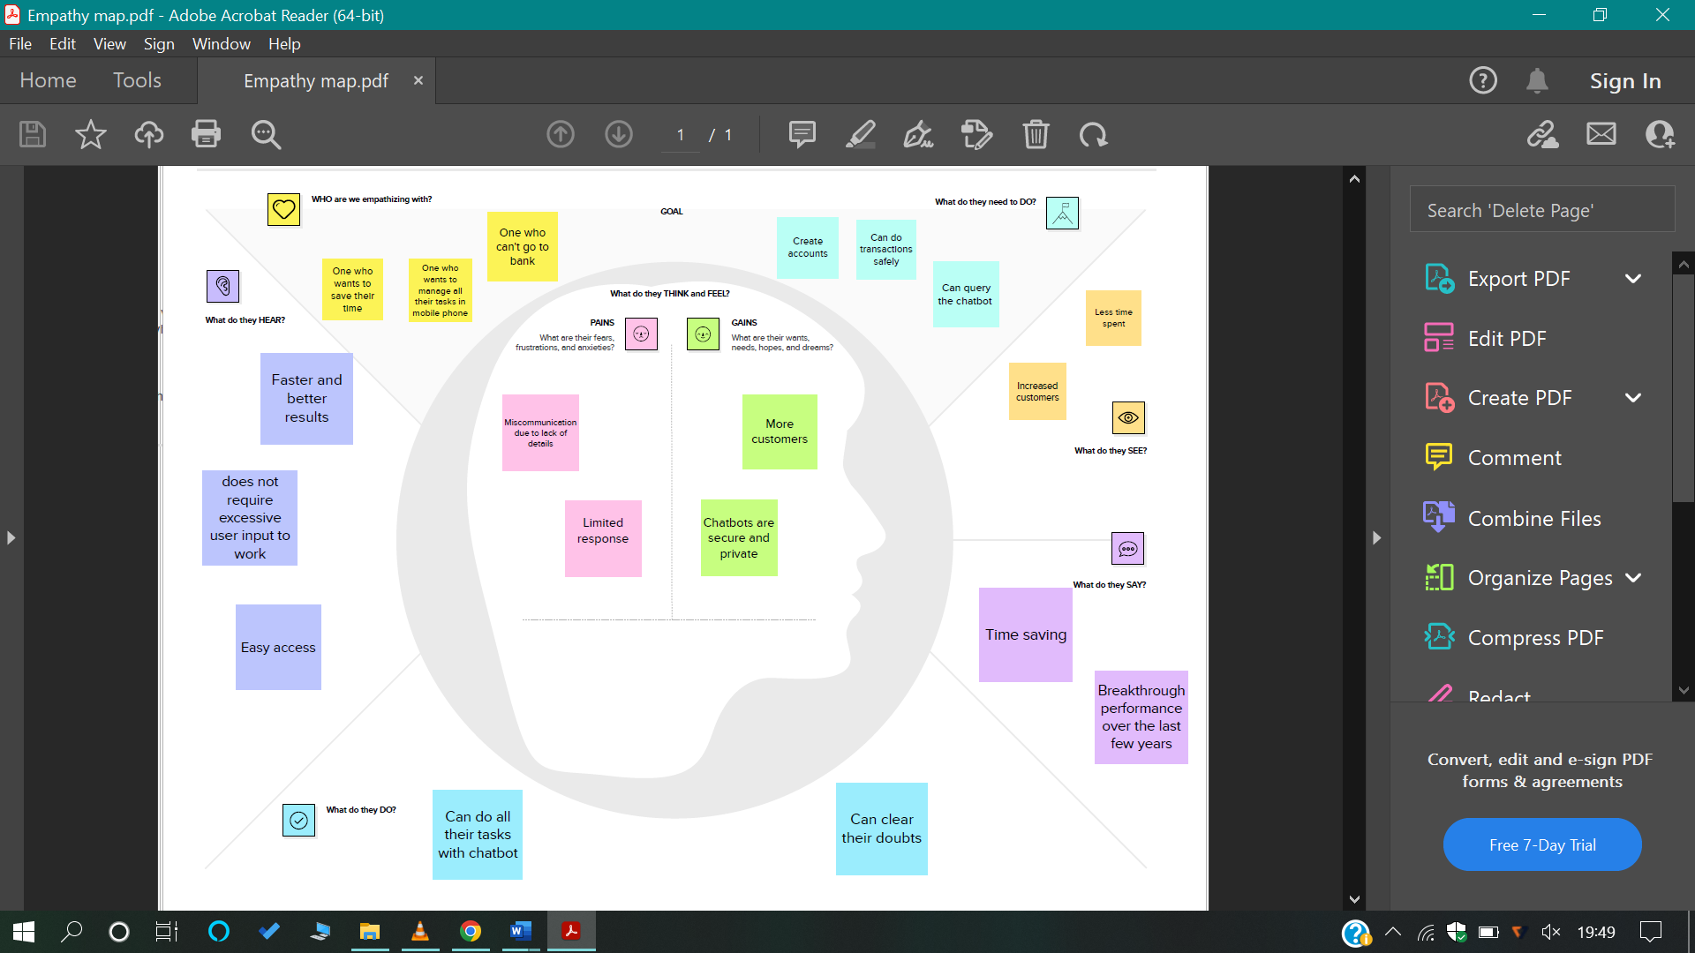

  - Ideation & Brainstorming

  - PROPOSED SOLUTION

S.No. | Parameter | Description
1. | Problem Statement (Problem to be solved) | Customers of the bank needs an assistant to assist them in online in many ways like getting payment link directly, answering their queries 24/7, loan queries, Net Banking  , Details related to banking,  Creating bank account ,connecting customer with the Bank Employee directly whenever needed, Live queries etc
2. | Idea / Solution description | To solve this Problem, we are going to design an AI Chatbot using IBM Watson Assistant which saves the Customer’s time and cost as they don't need to go bank directly. We are going to Deploy using Python Flask. We are also going to make use of many trending features such as NLP, NLU and IBM Cloud. We are going to train our model using Deep Learning. Our Chatbot will be built in such a way that it can Chat for hours without the need for human  supervision.
3. | Novelty / Uniqueness | - Integrated with IBM Watson Assistant and deployed using Python Flask  - 24/7 support  - Supports more than 10 languages  - Can be used in Offline  - adapts to customer needs and doesn’t break when deviations occur in conversations.  - Watson Assistant lets you protect and safeguard your customer conversations and data with IBM Security.

4. | Social Impact / Customer Satisfaction | People feel comfortable to use our Bot because they can interact using their native language. It can eliminate long wait times. Customers feel satisfied as they can do transactions anywhere and anytime. Our AI chatbot allows Customers to complete their entire process without waiting  so It saves the time of the Customers.
Customers are satisfied as it provides faster responses. Our Chatbot can make the Customers feel engaged and Customers wouldn’t feel that they are chatting with a machine. As the users doesn’t need any special hardware except their mobile for accessing the Bot, Customers can use
with ease.
5. | Business Model (Revenue Model) | As Chatbots are recent advancements in AI domain, not only banking sector, many organizations are integrating Chatbots with their website or mobile app. This Integration is considered as the Business model. In Banking sector, if we integrate Chatbot with their website, Customers need not come to Bank Directly which will attract more Customers in this fast pace world as many don’t have time to reach bank directly. Thus increasing the revenue of the Organizations with their increasing Customer and network. Bots can partially replace human bank staffs so you don’t need to pay full salary to replaceable human Staffs which benefits the organization in terms of  Finance.
6. | Scalability of the Solution | Organizations can quickly outgrow their planning solutions due to increased data volumes, users or increased complexity in planning models. This outgrowth can be handled by Our Chatbots as they can expand into different business domains, without impacting performance. Our Chatbot is scalable as it is dynamic and trained using AI and deep learning Models.  The best part of our Chatbot it can help the businesses to grow and scale with ease, especially when web traffic increases. Watson Assistant affirms that it can handle thousands of concurrent phone calls to support even the most demanding call center environments, by this we can understand that IBM Watson assistant is much scalable.

  - Problem Solution fit

- REQUIREMENT ANALYSIS
  - Functional requirement:
Visual studio code
IBM Watson studio
Flask

  - Non-Functional requirements:
Scalability
Availability
Compatibility
Reliability

- PROJECT DESIGN
  - Data Flow Diagrams

  - Solution & Technical Architecture

  - User Stories

User Type | Functional Requirement (Epic) | User Story Number | User Story / Task | Acceptance criteria | Priority | Release
Customer (Mobil or web user) | Current Account related actions | USN-12 | As a user, I want choose the Type of Company to know the information on documents to be submitted for creating current account | I can access my account / dashboard | High | Sprint-1
 |  | USN-13 | As a user, I want to receive details about the actions taken on my account. | I can receive information | High | Sprint-1
 |  | USN-14 | As a user, I want to get procedure and know about maintaining the account | I can get procedure and help. | Low | Sprint-2
 | Net Banking related actions | USN-15 | As a user, I want to know about maintaining the net banking account and its facilities | I can clear my queries regarding netbanking. | Medium | Sprint-3
 |  | USN-16 | As a user, I want to know about creating an account. | I can create an account for netbanking. | High | Sprint-3
 |  | USN-17 | As a user, I want to get the procedure details for adding beneficiaries to my net banking account. | I can clear my queries regarding netbanking. | Low | Sprint 3
 |  | USN-18 | As a user, I want to select types of fund transfers to get details regarding different services available in net banking | I can select types of fund transfers to get details regarding different services available in net banking | Low | Sprint 3
Administrator | Chatbot related actions | USN-19 | As an admin, I want to change responses to queries and modify them. | I can change responses to queries and modify them. | Low | Sprint 1
 |  | USN-20 | As an admin, I want to modify the UI and other options based on the feedback received from the user. | I can modify the UI and other options based on the feedback received from the user. | High | Sprint 1

- PROJECT PLANNING & SCHEDULING
  - Sprint Planning & Estimation

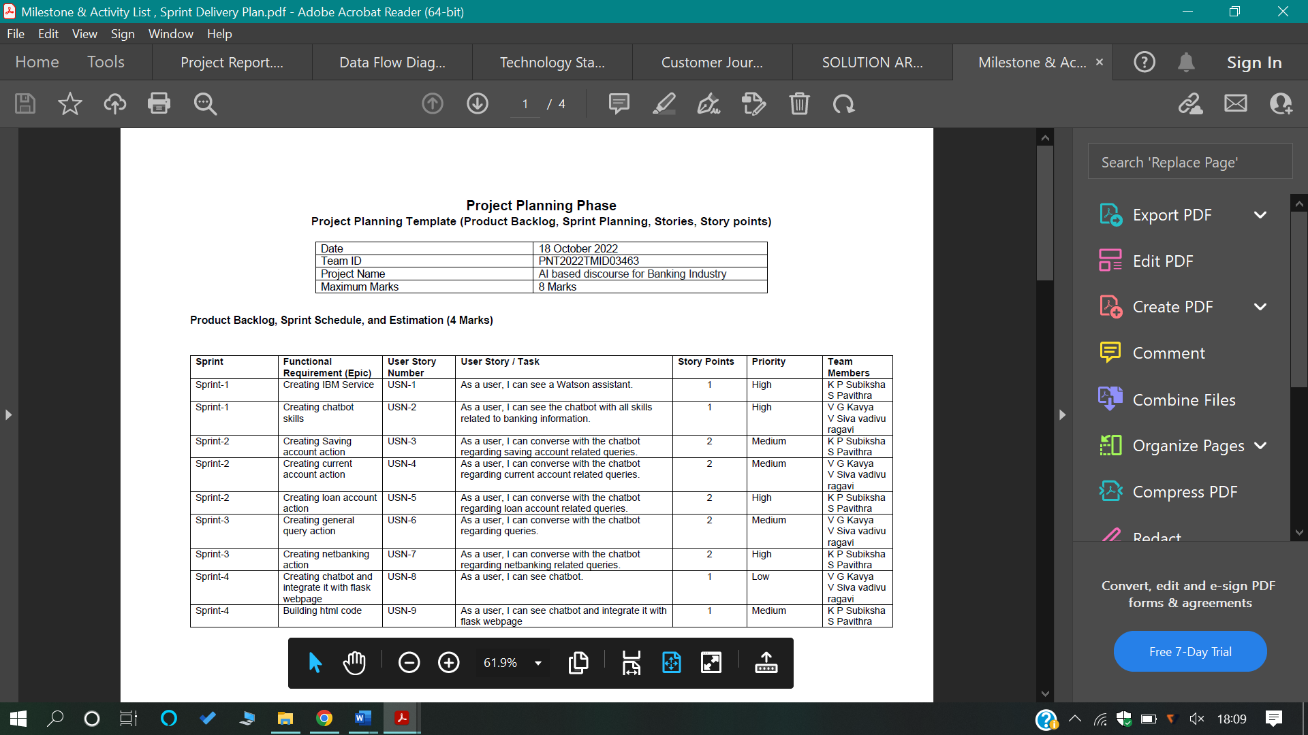

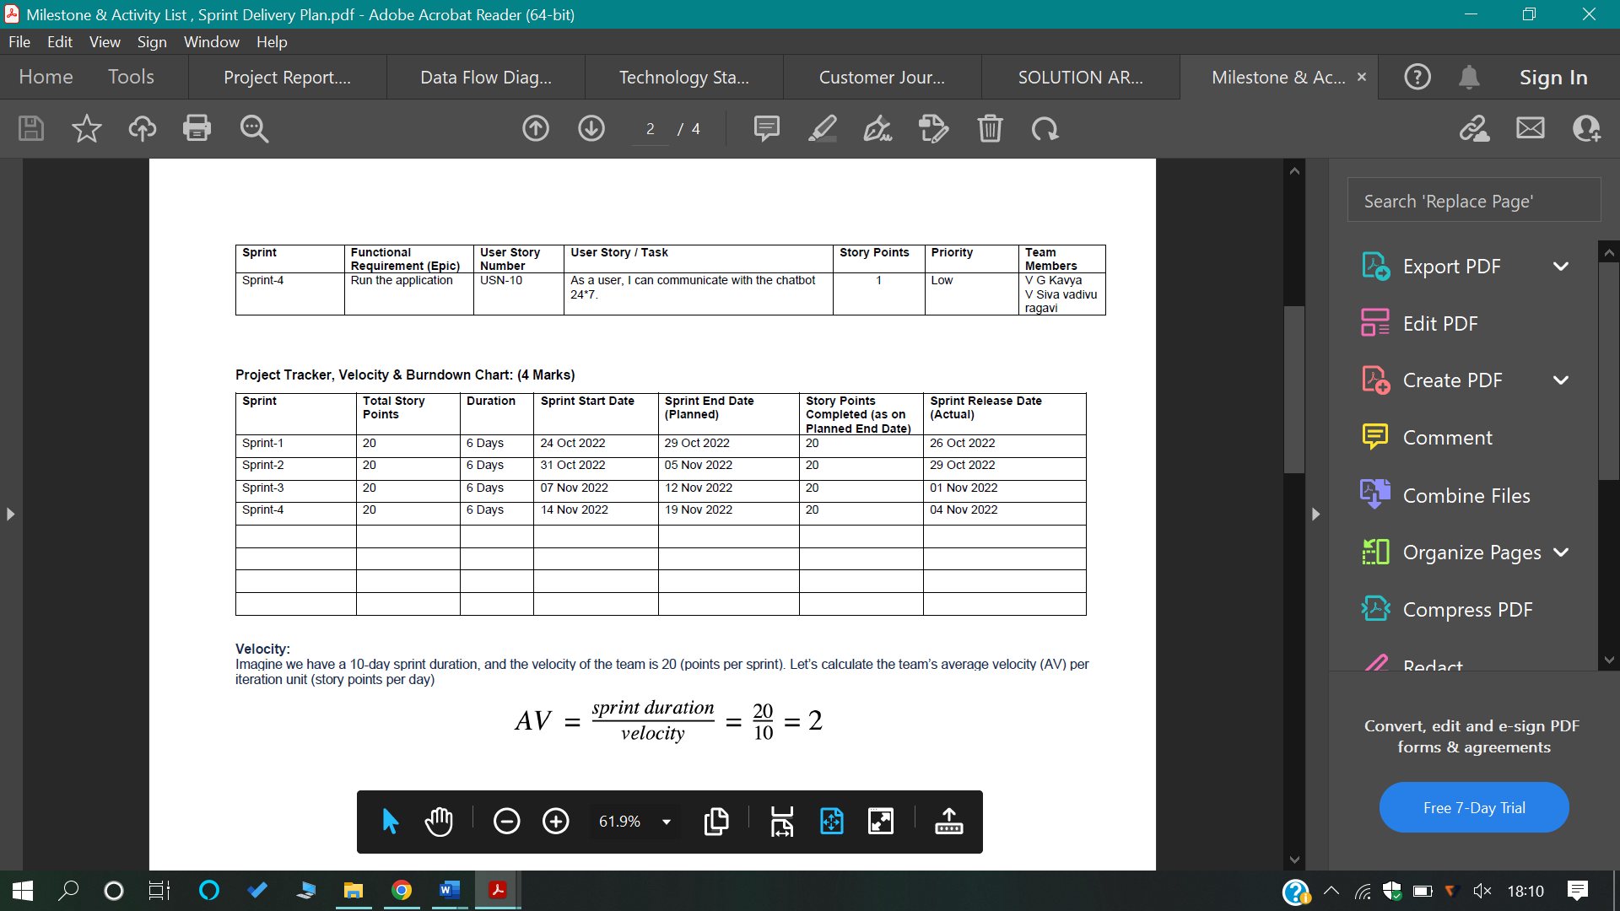
  - Sprint Delivery Schedule

- CODING & SOLUTIONING
  - Feature 1

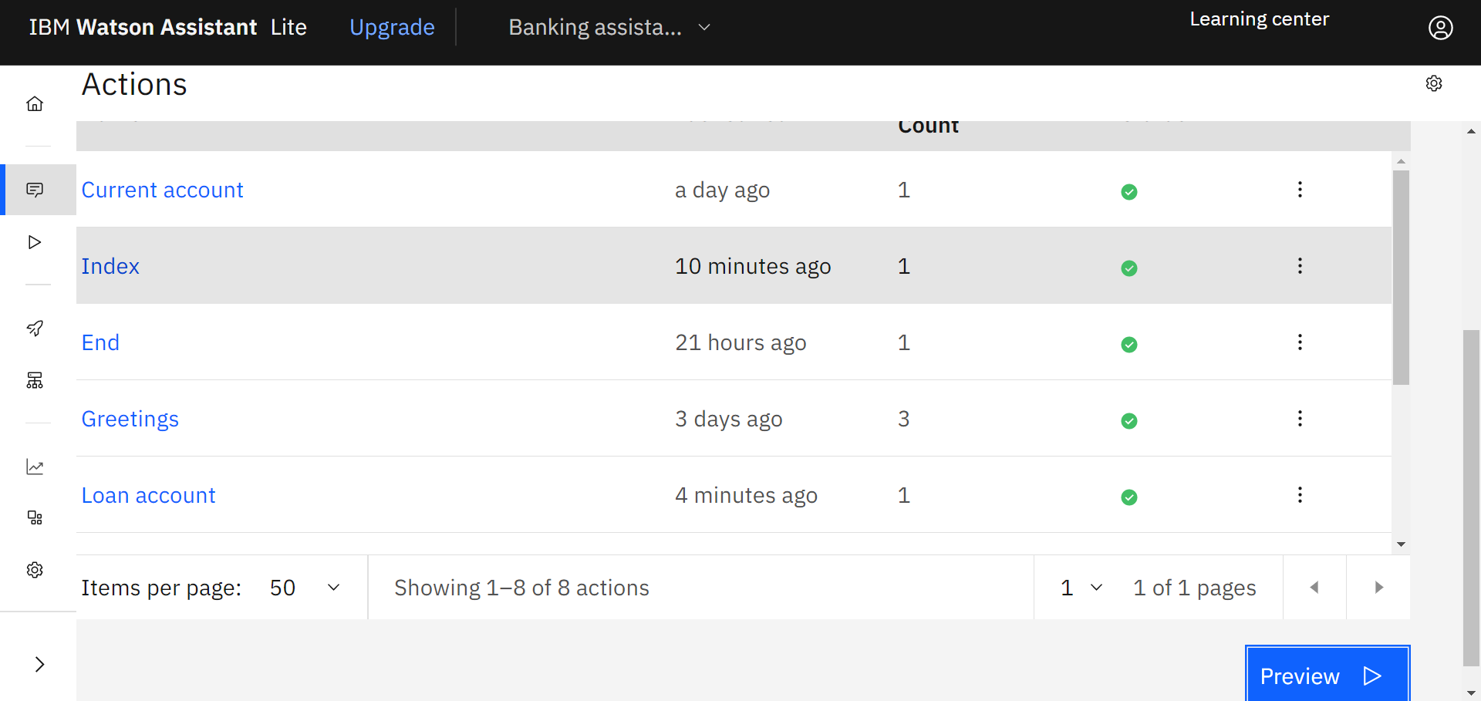

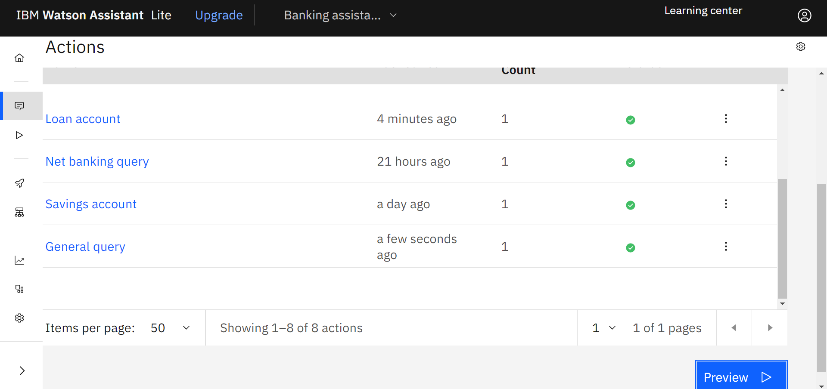

- TESTING
  - Test cases
Test case ID | Feature Type | Component | Test Scenario | Pre-Requisite | Steps To Execute | Test Data
LoginPage_TC_OO1 | Functional | Home Page | Verify user is able to see the Login/Signup popup when user clicked on My account button | --- | 1.Enter URL and click go  2.Click on My Account dropdown button  3.Verify login/Signup popup displayed or not | -
LoginPage_TC_OO2 | UI | Home Page | Verify the UI elements in Login/Signup popup | --- | 1.Enter URL and click go  2.User able to view chatbot icon | -
LoginPage_TC_OO3 | Functional | chatbot | Verify user is able to chat with the application system | --- | 1.Enter URL(https://shopenzer.com/) and click go  2.User able to view chatbot icon  3.Chat with the bot  4.Type the query and get the answer | -

  - User Acceptance Testing
Resolution | Severity 1 | Severity 2 | Severity 3 | Severity 4 | Subtotal
By Design | 10 | 4 | 2 | 3 | 20
Duplicate | 1 | 0 | 3 | 0 | 4
External | 2 | 3 | 0 | 1 | 6
Fixed | 11 | 2 | 4 | 20 | 37
Not Reproduced | 0 | 0 | 1 | 0 | 1
Skipped | 0 | 0 | 1 | 1 | 2
Won't Fix | 0 | 5 | 2 | 1 | 8
Totals | 24 | 14 | 13 | 26 | 77

8.3 Test case analysis
Section | Total Cases | Not Tested | Fail | Pass
Print Engine | 7 | 0 | 0 | 7
Client Application | 51 | 0 | 0 | 51
Security | 2 | 0 | 0 | 2
Outsource Shipping | 3 | 0 | 0 | 3
Exception Reporting | 9 | 0 | 0 | 9
Final Report Output | 4 | 0 | 0 | 4
Version Control | 2 | 0 | 0 | 2

- RESULTS
  - Performance Metrics

- ADVANTAGES & DISADVANTAGES
● Brand Consistency.
● Increased Productivity.
● Reduced Staffing Needs.
● Consistent Response Rate and Availability.
● Helps with Fraud Prevention.
● Chats can be saved.
● Lower costs.
Disadvantages:
● Questions must be programmed beforehand.
● Impersonal
● Must keep information up-to-date.
● Technology issues.

- CONCLUSION
Chatbots are becoming an integral part of the digital world. It is necessary that the customer needs are addressed as well as customers are satisfied through the business. Customer expectations are growing with increasing technological development. Customer satisfaction is very important to businesses and enterprises because if the customers are not satisfied with the service customers never return.
More and more banks tend to integrate chatbots into their mobile apps. This is a convenient way to stay in touch with their clients and, at the same time, reduce the involvement of human personnel. According to estimations calculated by Juniper Research, in 2023, chatbot interactions will save 862 million hours for banks, which equals to $7.3 billion cost savings worldwide.
Security concerns regarding the use of chatbots in the banking industry will persist in the future. The need for well-protected and reliable AI solutions will become a major driving force of digital technologies development. The reason is simple: people will agree to share their private information and access to their credit cards only with the most protected and trustworthy software solutions, including chatbots.

- FUTURE SCOPE
The share of banks that use AI solutions and chatbots in particular is constantly rising. As another factor, the use of smartphones and other smart devices is also a rapidly growing trend. These two driving forces determine the near future of artificial intelligence assistants in the banking industry.More and more features like integrating with bank account and security is developed in future.

- APPENDIX
Source Code

bot.py
from flask import Flask,render_template,request
#from flask import Flask,render_template,request
app = Flask(__name__,template_folder='templates')
@app.route('/')
@app.route('/test/<user>')
def test_html():
return render_template("chatbot.html")
if __name__ =='__main__':
app.run(debug=True)

chatbot.html
<html>
<head>
<meta charset="UTF-8">
<title>Output</title>
<link rel="stylesheet"
href="https://maxcdn.bootstrapcdn.com/bootstrap/3.4.1/css/bootstrap.min.css". >
<style>
body
{
background-image:url("https://www.chetu.com/img/banking/online-banking/sliderbg/online-banking-banner.jpg");
background-size:cover;
}
</style>
</head>
<body>
<h1><center>AI BASED DISCOURSE FOR BANKING INDUSTRY</center></h1>
<script>
window.watsonAssistantChatOptions = {
integrationID: "db404437-2b4b-403b-af99-3550dc8f7e23", // The ID of this integration.
region: "au-syd", // The region your integration is hosted in.
serviceInstanceID: "a7b88ace-17fe-4c21-8e96-9cdab0e20df1", // The ID of your service instance.
onLoad: function(instance) { instance.render(); }
};
setTimeout(function(){
const t=document.createElement('script');
t.src="https://web-chat.global.assistant.watson.appdomain.cloud/versions/" + (window.watsonAssistantChatOptions.clientVersion || 'latest') + "/WatsonAssistantChatEntry.js";
document.head.appendChild(t);
});
</script>
</body>
</html>

GitHub & Project Demo Link
GitHub link- https://github.com/IBM-EPBL/IBM-Project-34336-1660234342
Project demo link- https://drive.google.com/file/d/1Q6jmZ_laCtNB5OQM5B9bcnSRB-Bjjgnn/view?usp=drivesdk

